Experiment no 6

AIM: - Design of 2:1 Mux by conventional method and by using Transmission gates and

comparison of them

OBJECTIVE: - To study importance of transmission gate.
THEORY: -
Both NMOS devices and PMOS devices exhibit poor performances when transmitting one particular logic information. The nMOS degrades the logic level 1, the pMOS degrades the logic level 0. Thus, a perfect pass gate can be constructed from the combination of nMOS and pMOS devices working in a complementary way, leading to improved switching performances.
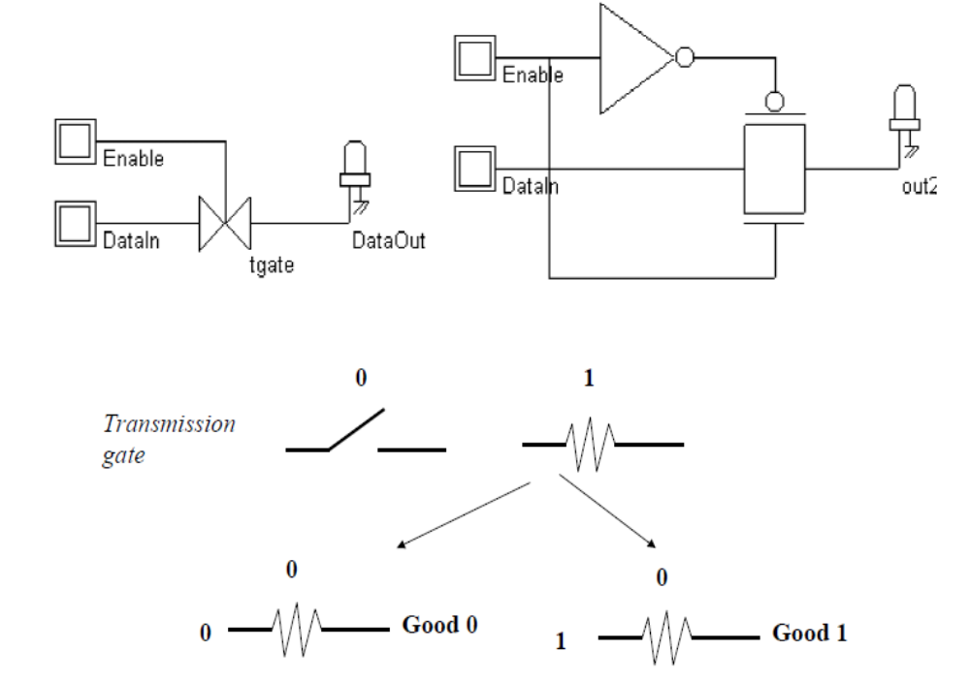

Simple transmission gate:
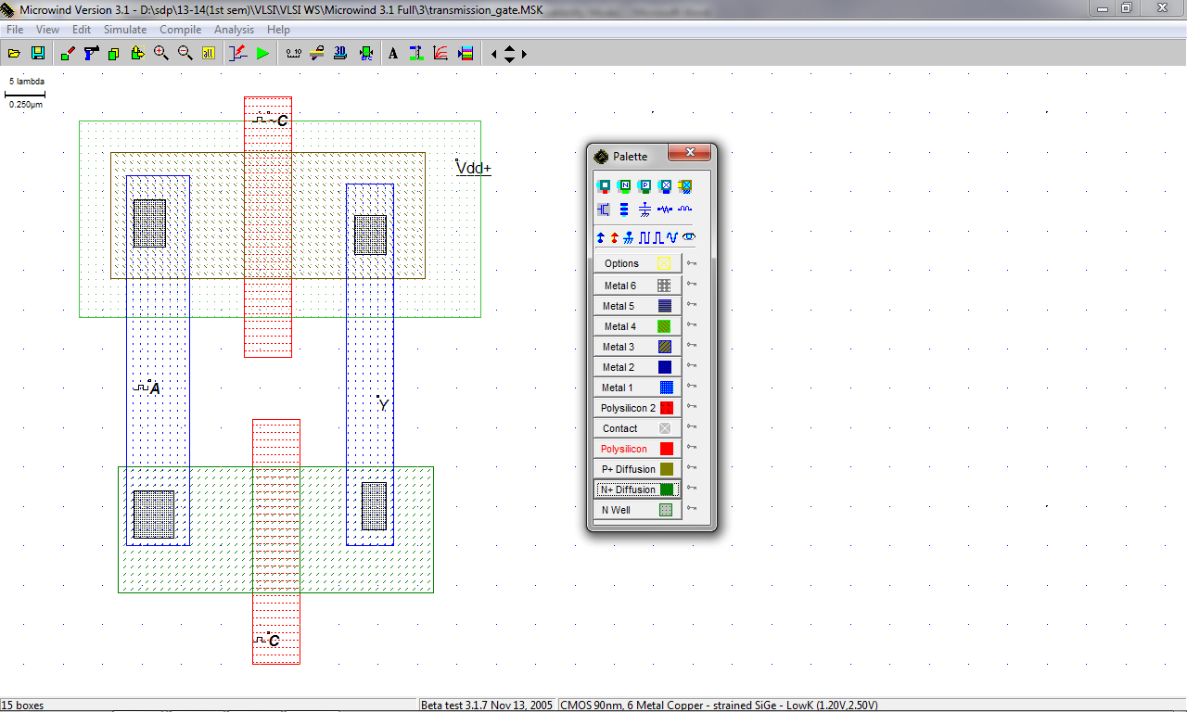

Waveform:
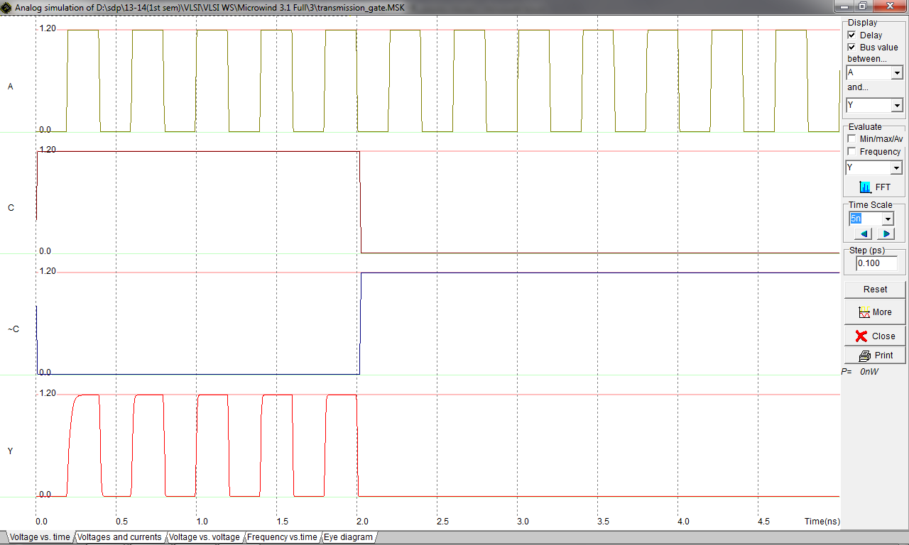

2:1 MUX using transmission gate (1)
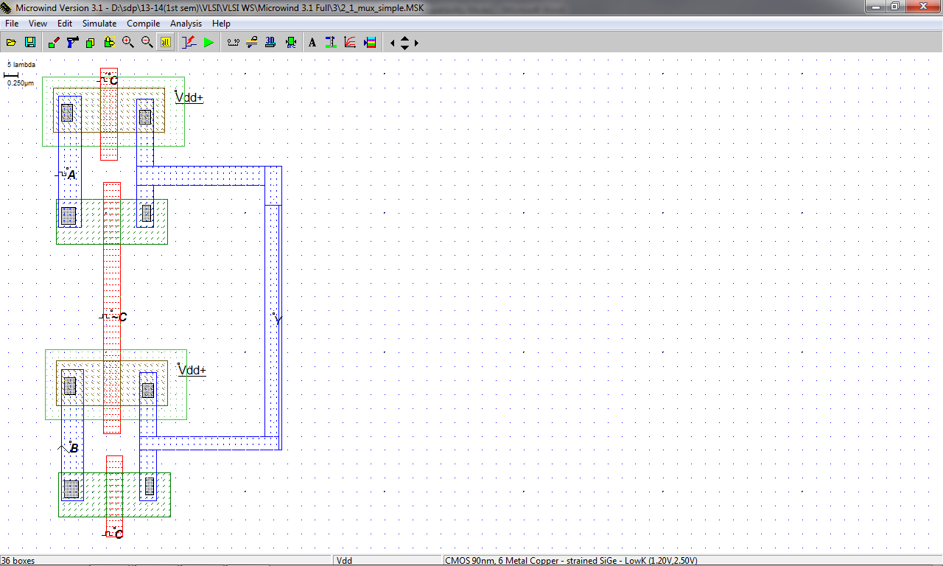

Waveform:
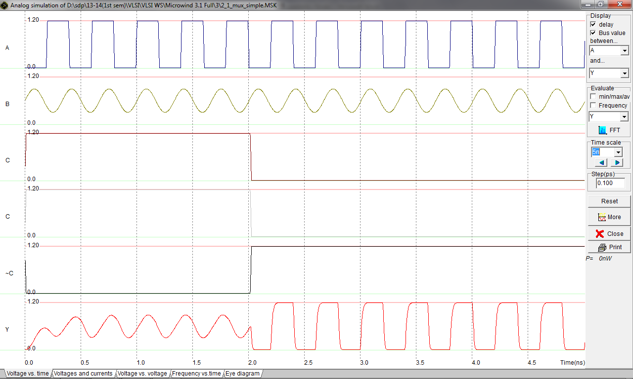

2:1 MUX using transmission gate method (2):
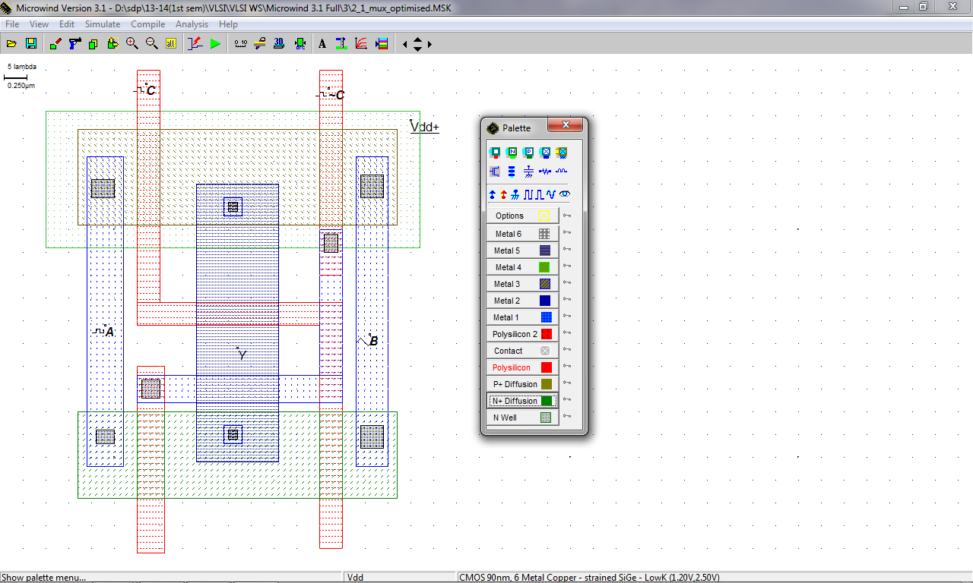

Waveform:
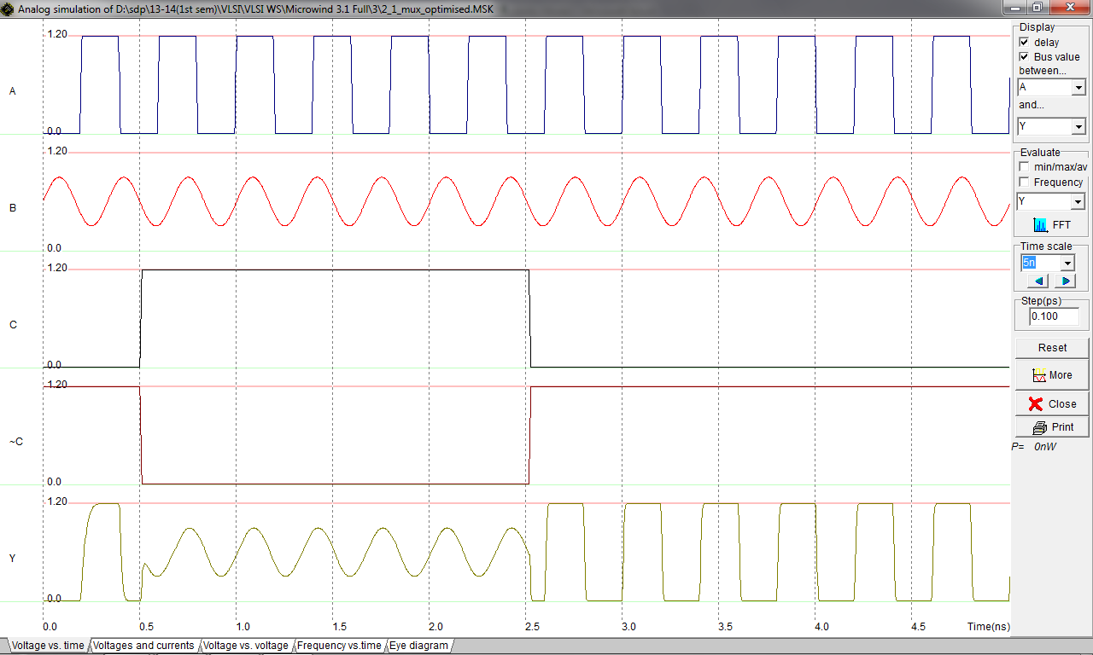

2:1 MUX using Conventional method:
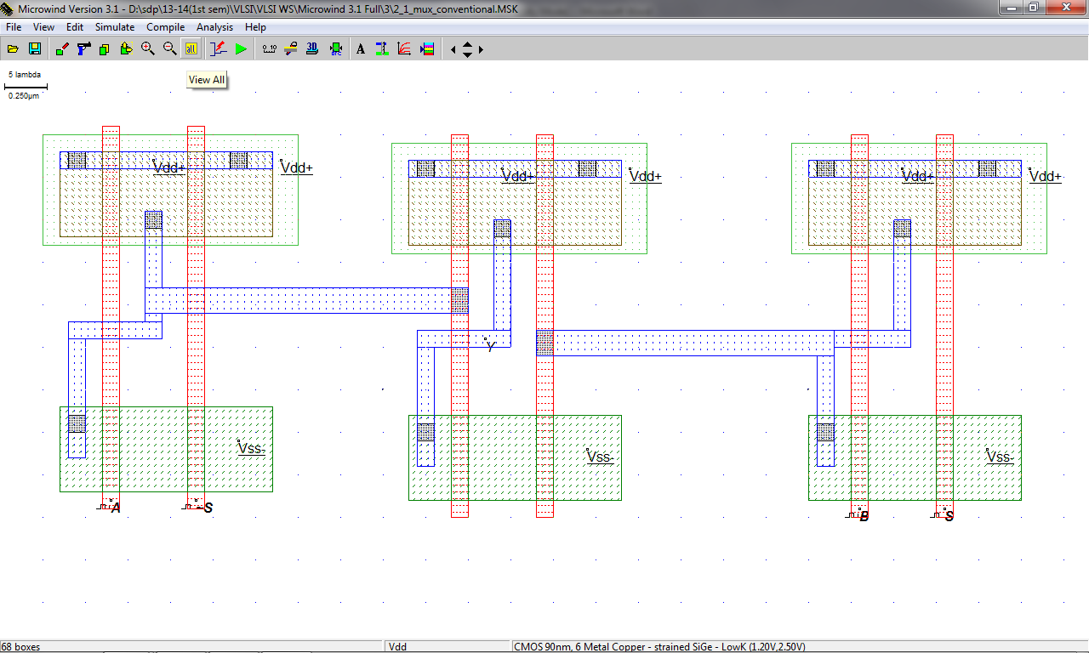

Waveform:
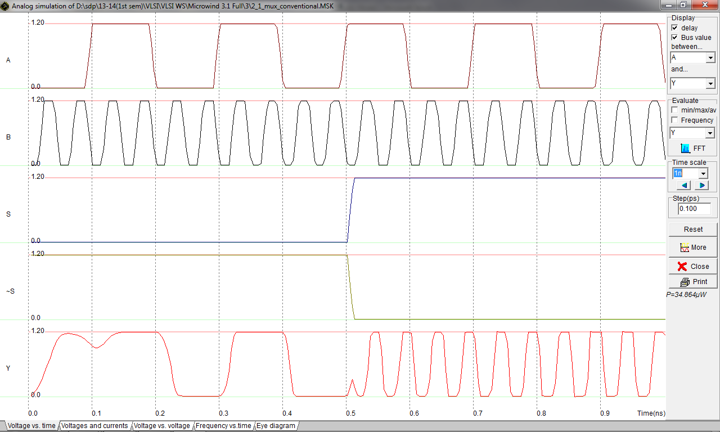

Conclusion: -

